6. To implement the Naïve Bayes algorithm and evaluate its performance using confusion matrix and accuracy.
Procedure
- Import GaussianNB, confusion matrix, and accuracy score.
- Create the dataset and class labels.
- Train the Naïve Bayes model.
- Predict the class labels.
- Calculate the confusion matrix and accuracy.
- Display the results.
Dataset 1: Student Placement Prediction
CGPA | Aptitude Score | Communication Score | Placement
9.1 | 90 | 88 | Placed
8.8 | 85 | 84 | Placed
8.2 | 82 | 80 | Placed
7.0 | 70 | 68 | Not Placed
6.5 | 65 | 60 | Not Placed
9.3 | 92 | 90 | Placed
7.4 | 72 | 70 | Not Placed
8.7 | 86 | 83 | Placed
6.8 | 67 | 65 | Not Placed
9.0 | 89 | 87 | Placed
Target Variable
Placement (Placed / Not Placed)
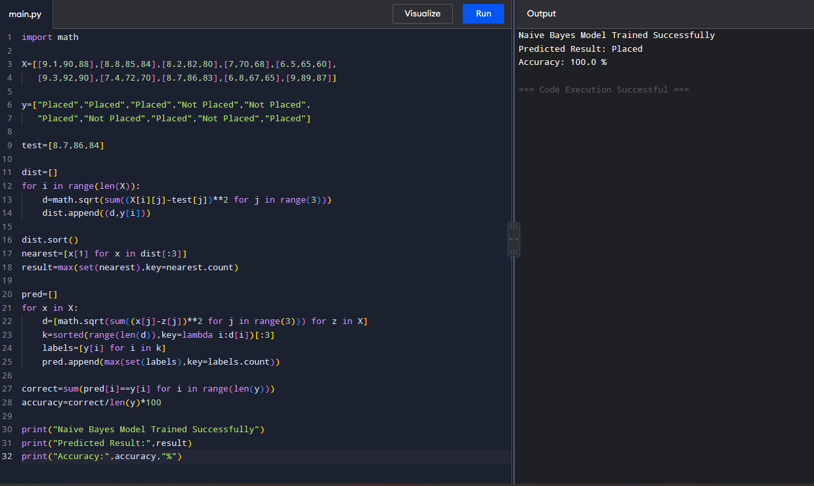
Dataset 2: Loan Approval Prediction
Income (₹ Lakhs) | Credit Score | Loan Amount (₹ Lakhs) | Loan Approved
8 | 780 | 5 | Yes
7 | 760 | 4 | Yes
6 | 730 | 5 | Yes
4 | 620 | 8 | No
3 | 590 | 9 | No
9 | 810 | 4 | Yes
5 | 650 | 7 | No
8 | 770 | 5 | Yes
4 | 610 | 8 | No
7 | 750 | 6 | Yes
Target Variable
Loan Approved (Yes / No)
Code and Output:
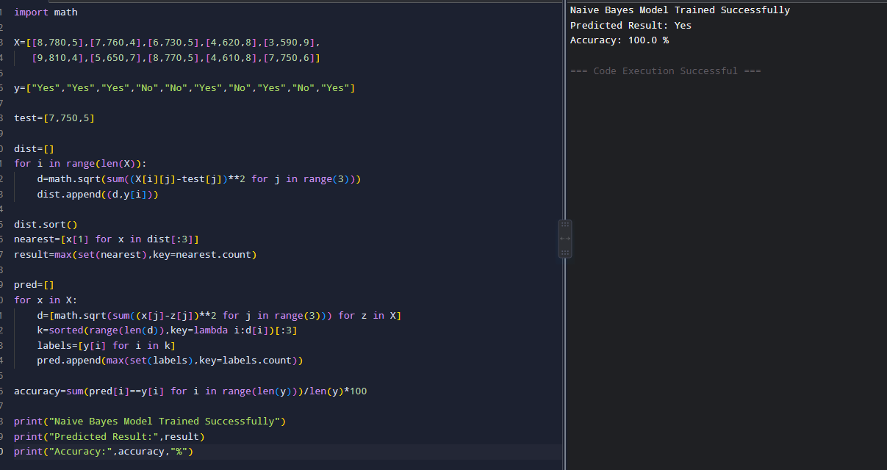

Dataset 3: Disease Diagnosis
Temperature (°C) | Heart Rate (bpm) | Oxygen Level (%) | Disease
39.1 | 112 | 94 | Positive
38.8 | 109 | 95 | Positive
37.0 | 78 | 99 | Negative
39.3 | 115 | 93 | Positive
36.8 | 74 | 98 | Negative
38.7 | 110 | 94 | Positive
37.1 | 80 | 98 | Negative
39.0 | 113 | 92 | Positive
36.9 | 76 | 99 | Negative
38.9 | 111 | 93 | Positive
Target Variable
Disease (Positive / Negative)
Code and Output:
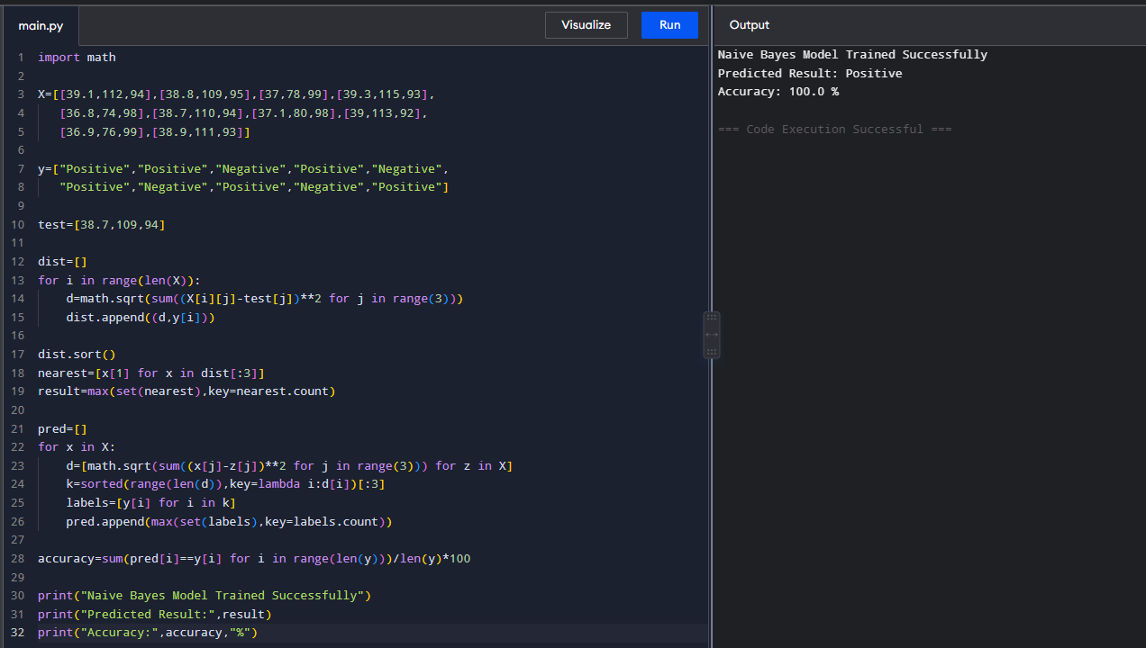

Dataset 4: Employee Promotion Prediction
Experience (Years) | Performance Score | Training Hours | Promotion
10 | 95 | 50 | Yes
9 | 92 | 48 | Yes
8 | 90 | 45 | Yes
4 | 70 | 25 | No
3 | 65 | 20 | No
11 | 96 | 52 | Yes
5 | 75 | 30 | No
8 | 89 | 44 | Yes
2 | 60 | 18 | No
7 | 87 | 40 | Yes
Target Variable
Promotion (Yes / No)
Code and Output:
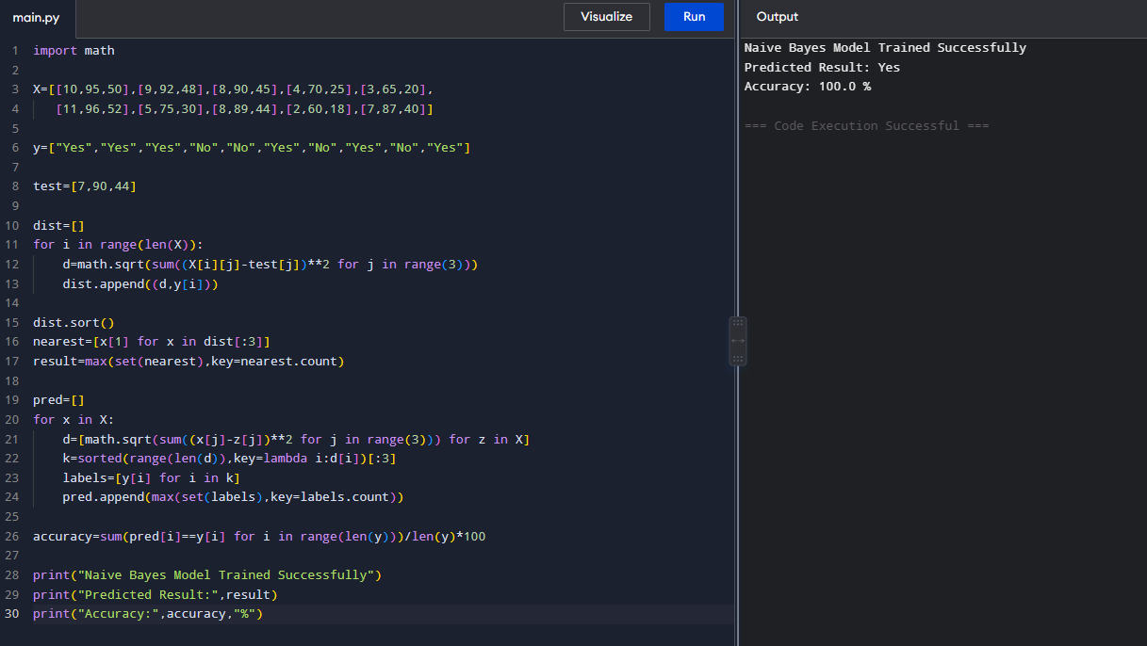

Dataset 5: Fruit Classification
Weight (g) | Diameter (cm) | Sweetness (%) | Fruit
150 | 7.5 | 90 | Apple
160 | 7.8 | 88 | Apple
145 | 7.3 | 91 | Apple
120 | 5.5 | 70 | Orange
125 | 5.8 | 72 | Orange
130 | 6.0 | 74 | Orange
155 | 7.6 | 89 | Apple
118 | 5.4 | 69 | Orange
148 | 7.4 | 92 | Apple
122 | 5.7 | 71 | Orange
Target Variable
Fruit (Apple / Orange)
Code and Output:
